**End assignment report OPS**

[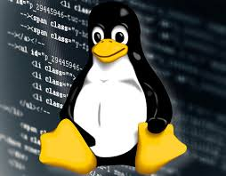](https://www.google.nl/imgres?imgurl=https://tr3.cbsistatic.com/hub/i/r/2016/06/02/e965310b-b38d-43e6-9eac-ea520992138b/resize/770x/8e291bfbf9962bd2bb3f256ef3c5f5c8/linuxadminhero.jpg&imgrefurl=https://www.techrepublic.com/article/how-to-create-users-and-groups-in-linux-from-the-command-line/&docid=5bldd9G5N1lfLM&tbnid=6vXRBh6amUy9JM:&vet=10ahUKEwihnZ-rrubYAhUQJOwKHXAFBDcQMwhcKBgwGA..i&w=770&h=602&safe=strict&bih=713&biw=1455&q=linux&ved=0ahUKEwihnZ-rrubYAhUQJOwKHXAFBDcQMwhcKBgwGA&iact=mrc&uact=8)

**Reinier van Leeuwen**

**590885**

**ENG-HESE**

**20-01-2018**

**Marc van de Sluys**

Inhoud

Questions: 3

# 

# Questions:

**Question 3.1: Disc use**

1. How much of your disc (SD card) has been used by the base system? “ 852,292 MB

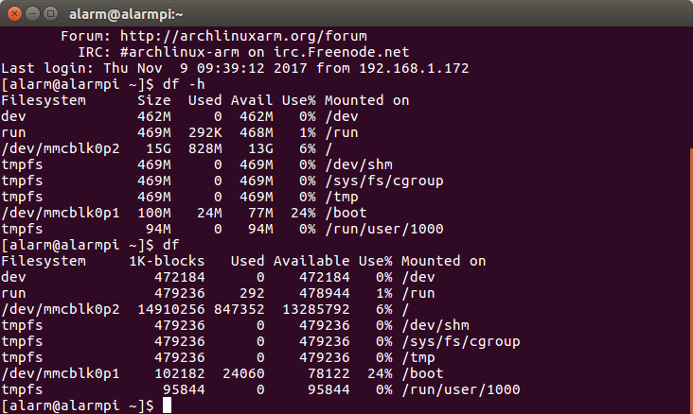

1. How does the output look without the -h flag?

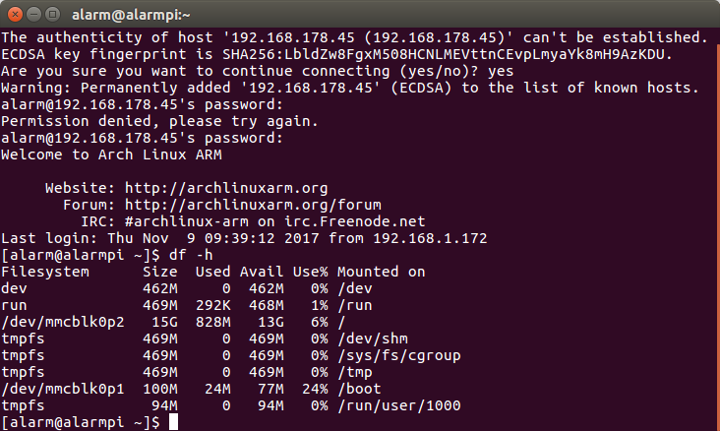

**Question 3.2: Memory use**

• How much of your memory does the base system use? 33 MB

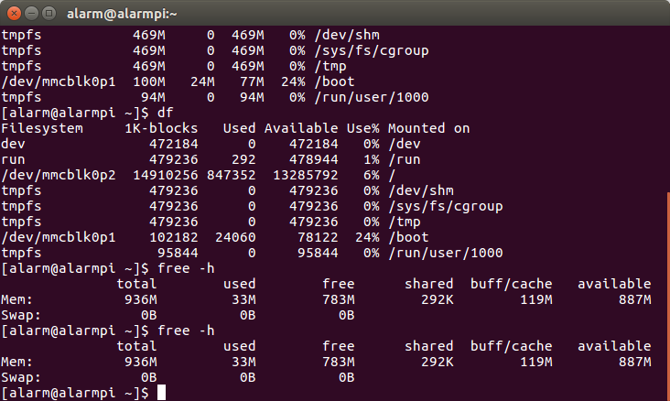

**Question 4.1: How can you tell whether a package is installed?**

When no conflicts are found.

**Question 4.2: Which version did pacman install? 2.15.1-1**

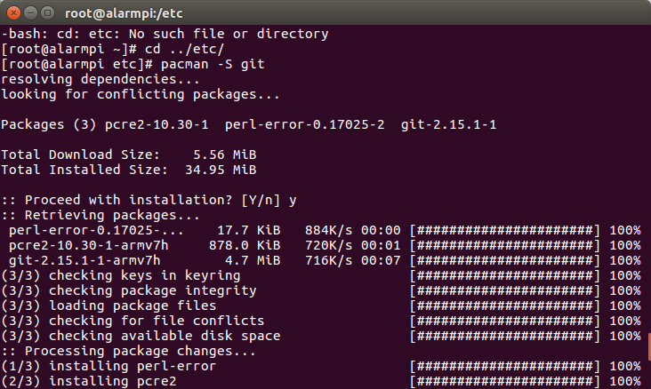

**Question 4.3: When was the last commit made in your local repository? When on the server?**

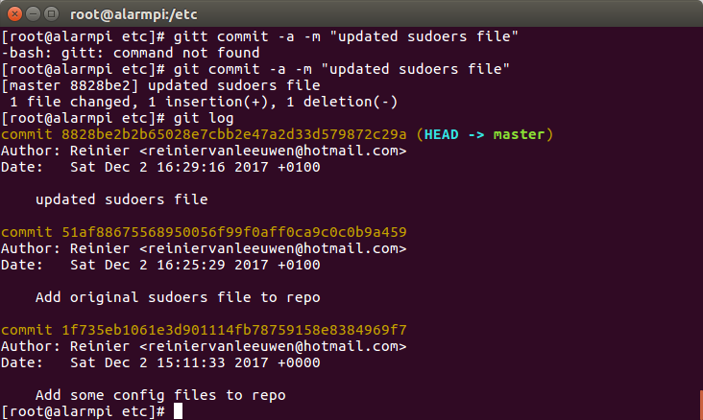

**Question 5.1: Which packages were updated?**

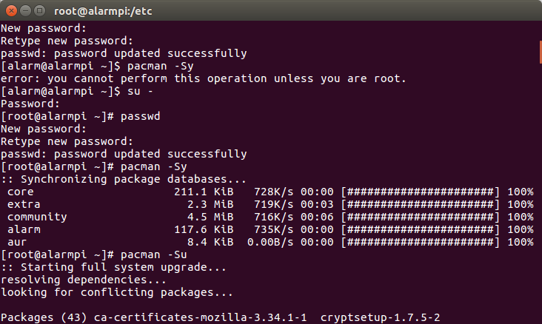

**Question 6.1:** What happens when you try to install etc-update as root?

==> ERROR: Running makepkg as root is not allowed as it can cause permanent,

catastrophic damage to your system.

**Question 7.1:** What message do you see when you try to log in over ssh as user alarm? Permission denied, please try again.

**Question 7.2:** Are you asked to confirm whether the file should be deleted? rm: remove write-protected regular file 'temp.txt'?

**Question 7.3:** Are you asked to confirm whether the file should be deleted this time? rm: remove write-protected regular file 'temp.txt'?

**Question 8.1:** Which colours are used for both users? wit

**Question 8.2**: What colour do the flags (-m, etc.) in the SYNOPSIS line have?

Blauw

**Question 8.3:** What colour do the options (system, etc.) in the same line have?

Rood

**Question 8.4:** At which option does the first hit occur?

the manual. The default action is to **search** in all of the available

**Question 9.1:** From which website/URL will the package be downloaded? url="https://github.com/han-ese/Arch-RPi"

**Question 9.2:**  On which other packages does this package depend? depends=('bash' 'python3' 'python-sense-hat')

**Question 9.3:** Which script does the service run when it is started? And when it is stopped?

Started: ExecStart=/usr/bin/han-ese-ops_run-at-boot.sh &

Stopped: ExecStop=/usr/bin/han-ese-ops_run-at-shutdown.sh &

**Question 9.4:** Which message is printed on shutdown? And which on boot?

Booting alarmpi “linux” Eth 0 … … … …

Shuting down alarmpi

**Question 9.5:** What happens to the SenseHAT when you log in? What happens when you **su** to root? The logged in message comes on the screen (opsstudent logged in).

**Question 10.1:** Which line in which file sets the permissions that allows anybody to access the I2C device? crw-rw-rw- 1 root root 89, 1 Dec 21 13:31 i2c-1

**Question 10.2:** What is the output of the command? 2017-12-30 10:56:18 29.1 45.8 0.0

**Question 10.3:** What happens if you replace >> with > in the previous command?

The first line in the weather.log file is overwrite every time when you push.

# Ssh:

Login: ssh [opsstudent@___.___.___.___](mailto:opsstudent@___.___.___.___)

Poort: 32123

Password: OPSpass

Root: OPSpass